Night
The Geographical Journey
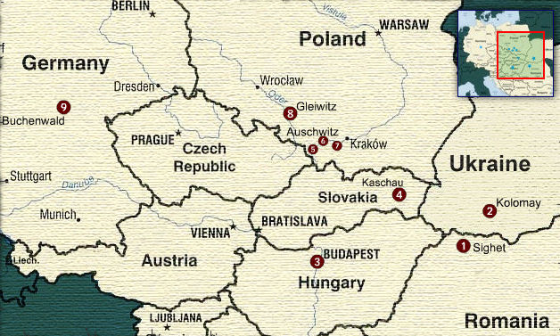

- Sighet: Eliezer Wiesel was born in Sighet, Transylvania (modern-day Romania) in 1928. In 1944, the German Gestapo and the Hungarian police force Sighet’s Jewish citizens into ghettos. Then, they deport them by train—80 persons to every cattle car.
- Kolomay: The Hungarian police expel Moishe the Beadle and the other foreign Jews from Sighet. The Gestapo takes control of the train once it reaches Polish territory (now part of Ukraine) and executes the Jews in the Galician forests near Kolomay (Kolomyja).
- Budapest: In 1944, German troops enter Hungary with the newly elected government’s approval. Stories of anti-Semitism in Budapest reach Sighet, but the Jewish citizens still think they are safe.
- Kashau: Two days after leaving Sighet, the train stops in Kashau near the Czechoslovakian border (Kosice in modern-day Slovakia). The German Army takes control of the train.
- Birkenau: Seconds after stepping off the train, Eliezer and his father are separated from his mother and sisters forever. Part of the Auschwitz complex, Birkenau was built after the 1942 Wannsee Conference in Berlin and quickly became the Nazi’s largest killing center. It is estimated that 1.1 million Jews, 75,000 Poles, 21,000 Gypsies and 15,000 Soviet prisoners of war perished in its flames.
- Auschwitz: Eliezer and his father are introduced to the motto Arbeit Macht Frei (Work Makes You Free) at Auschwitz. As the Soveit Army advances in the fall of 1944, the Nazis evacuate the Auschwitz complex sending the prisoners on foot and by cattle car to other camps. The Soviet Army liberates the few who remain in January 1945.
- Buna: Also known as Auschwitz III, Buna is a smaller work camp about a four-hour walk west of Auschwitz. Eliezer and his father are sent to Buna to work in a warehouse sorting electrical parts.
- Gleiwitz: In January, Eliezer and his father are evacuated from Auschwitz and forced on a two-night death march to Gleiwitz (Gliwice). They run more than 20 kilometers (about 13 miles) through the snow before stopping. After three days in Gleiwitz, a transport train for Buchenwald arrives—this time each cattle car carries 100 Jews.
- Buchenwald: For three days and nights, Eliezer and the other prisoners ride the train from Gleiwitz (Gliwice) in Poland to Buchenwald (near Weimar) in Germany with no food or water. Only 12 of the 100 men in Eliezer’s car survive. Eliezer and about 20,000 prisoners are liberated on April 11, 1945.

