Blame
By: Tiler Jean

My heart is exploding. I’m scared and she is getting closer. I can hear her footsteps slowly walking down the wood floored hallway. Is this how I’m supposed to die?

January 1st

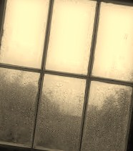It’s raining outside. I can’t see it but I can hear the soft drops of water hitting the windows upstairs. It soothes my nerves for a while. I’m lying in my room. It’s so dark that you can’t even see your own hand. The sounds of feet alert me that someone is home. I lay here hoping they won’t come looking for me. Hoping they will leave me be for just awhile longer. They don’t.

The De-mom comes strutting in. I call my mother the De-mom cause she is basically the demon of the house. She can push my buttons more than anyone and she knows it. I sit up waiting for her to tell me what I have done wrong for today.

She is standing with her usual stance and grimace. De-mom was once a beautiful woman. She had long black hair like ink. And Brown eyes that were filled with love. I guess the years of sadness and drugs have taken a tole on her. It’s taken a toll on all of us.

“Are you just going to sit in this room all day?” She is tapping her foot impatiently. Something or someone has pissed her off. I get up from my bed and walk to my closet. De-mom follows and I can faintly hear her talking. I’ve learned to block out the yelling as much as possible. I grab my loose black pants and one of my boyfriend’s t-shirts that he had left here. I’m walking to my bathroom when I notice that I haven’t seen my little sister yet.

I turn to De-mom to ask where she is but stopped short of it because she wouldn’t know where her daughter is. I’ve learned to take care of my little sister Sheala because De-mom is always too busy with work, drugs, or my older sisters. She says she loves us just as much as they but it’s a lie. If they do something wrong then she babies them. It’s completely different with us. We getting yelling and screams with a side of threats. I call it life but I will be damned if Sheala ever gets to be like me.

I go into my bathroom. I slam the door smack into De-moms face. She didn’t like that to much but the door is locked. I can hear a faint yelling over my shower. It feels like this is my only time to relax from all the stress of my life. It didn’t always use to be like this.

January 5th

I can hear this this noise. It’s loud and annoying. I roll over in bed and realize it’s my alarm clock. It’s seven in the morning. I hit the snooze button. I can’t stand to wake up from sleeping on a normal day but i really can’t today. I lie back down and throw my arm back around my boyfriend’s waist. It’s nice to wake up beside him. At least i know i'm safe here.

The alarm goes off ten minutes later. I quickly hit the off button. I get my lazy butt up. It’s a Tuesday and i have to go to school. I’m standing in front of the dresser looking at my hair. It’s a complete wreck. My boyfriend comes up behind me and just laughs. He has his arms around me and is kissing my neck. “Not this morning, Sweetie. I have to go to school.” I look at him with a small smile. He kisses me and goes off into the kitchen. I’m just about to go into the bathroom when he calls for me. “I don’t think you’re going to school today, Baby-Girl.”

It’s snowing outside. Winter has never been my thing but my boyfriend, Jakob, loves it. He likes when it snows and he can go riding his four-wheeler around. He is such a child at heart. My dad never approved too much of Jakob. He never missed a chance to tell me, “He is nineteen, has tattoos, and no job. God forbid you get a decent guy for once.” It pissed me off more than anything.

Jakob has no job right now and i’m fine with that. I know it will make things difficult on us but for now it’s okay. The thing with Jakob is that he treats me like i’m a princess. I can’t help but fall for him. His strong arms around my waist make me feel safe in this unstable world.

“What do you want for breakfast baby?” He is looking at me with those perfect eyes and i can’t help but smile. “Don’t answer that. I know exactly what you want.” He laughs and goes to the fridge. Staring out the window at the snow is like a numbing feeling. My mind drifts off to a different place and time from here.

I’m eight years old. I’m playing in the snow with my dad. We are throwing snow balls and laughing. My dad has always been one of my heroes and friends. He runs and snatches me up into his arms and swirls me around. I feel safe. I feel loved.

I snap back into reality when Jakob says breakfast is ready. I eat without really tasting. I’ve had something i have been meaning to tell Jakob the past four months but never had the guts to say. He could leave me and it’s scary because he is one of the few happy things in my life. I go sit on the couch in the living room of his apartment. He comes and kneels in front of me. “What is wrong Baby-Girl? You have been acting strange the past few weeks. You’re starting to make me nervous.”
“Jakob I have some big news. Please don’t be mad. I’m Pregnant.” I state it very quietly. I hold my breath waiting for him to get angry and yell. Instead, he takes my hand and holds it tight. “Why would I be mad? It may not be the best thing to hear at a young age but I could never be mad at something that I helped create.”

He pauses and looks down at my hand that he is still holding. “You are carrying a life that will know hard times but will always know that it is loved. I know you are scared but this child will not go through what you did. You will not become your mother.”

I start to cry. I can’t help it. All my life I have felt like nothing. De-mom has made me feel like I will never amount to nothing and here is this guy saying that everything will be okay. He takes me into his arms and we lay there for hours on the couch. I can’t remember a time in my life that I’ve felt so accepted. Jakob leans my head up so I am looking right into those hypnotic gems. “You will always, for now and forever, be my sweet Clara.”

January 8th

“I’m scared.” Sheala says with sadness. I turn to where she is sitting on her bed. She looks so small and fragile. Her usually curly light brown hair is flat and dull. She has lost so much weight since the accident. She is looking at me with her brown eyes that have sunk slightly into her skull. My poor little sister, even in the worst of her moments, is still beautiful.

I go and sit on the edge of her bed. It’s a small bed but it’s a bed at least. “I know you are. The thing is I am too. However, I refuse to lose hope. Things will get better. It may be hard right now but you don’t need to worry. I will take care of you.” I lean over and kiss her forehead. Just as i’m about to walk out her bedroom door, Sheala Repeats “I’m scared Clara. I didn’t mean for that night...” She stops short of finishing. I lean my head against the edge of the door. “I know you didn’t. None of us did.”

I run to my room and close the door ever so softly. I can’t help but think of my dad. He use to get onto me because i would close my door to quick and it would make a loud booming noise. I can’t make a sound with the door or I’ll remember him all too much. I jump on my bed. I slide into a dream effortlessly; all though, it feels like a nightmare.

It’s dark and cloudy. I’m sitting in the living room reading a book. I can just barely hear my dad say he is going to pick my sister up from the movies. I throw the book down on the chair and run to him. “Can I come with?” I hurriedly ask. He looks at me and smiles. His eyes are like crystals and his smile as warm as a summer sun. “I think you’re more into your book then to come with me right down the road. Am I right?” I shyly look down because he is right. I’m engulfed in it. I hug him just so i can feel his love and warmth. “I’ll be back soon.” He says as he is hugging me. I pull back to look up at his face. It’s changed. His eyes are pale white. His skin clear as a ghost. He is melting in my arms. I feel a sharp pain in my throat and realize i’m screaming.

I wake up in my bed. I don’t move. I don’t think i could if i tried. I’m paralyzed with fear. It’s still daylight outside but in this house it feels like it’s the darkest depths of hell.

January 12th

The front door slams. The family picture that hangs on the wall falls to the floor and breaks again. De-mom has broken that frame four times since the accident. I bend down to clean up all the glass. De-mom looks down in disgust at me. She grabs me by the arm and yanks me up. “What the hell do you think you’re doing? No matter how many times you put that picture back up it isn’t going to bring your father back!” I can smell alcohol on her breath. I also notice her right sleeve has a dot of blood near the inside crease of her elbow. She is drunk and high on her drugs. Will things never change?

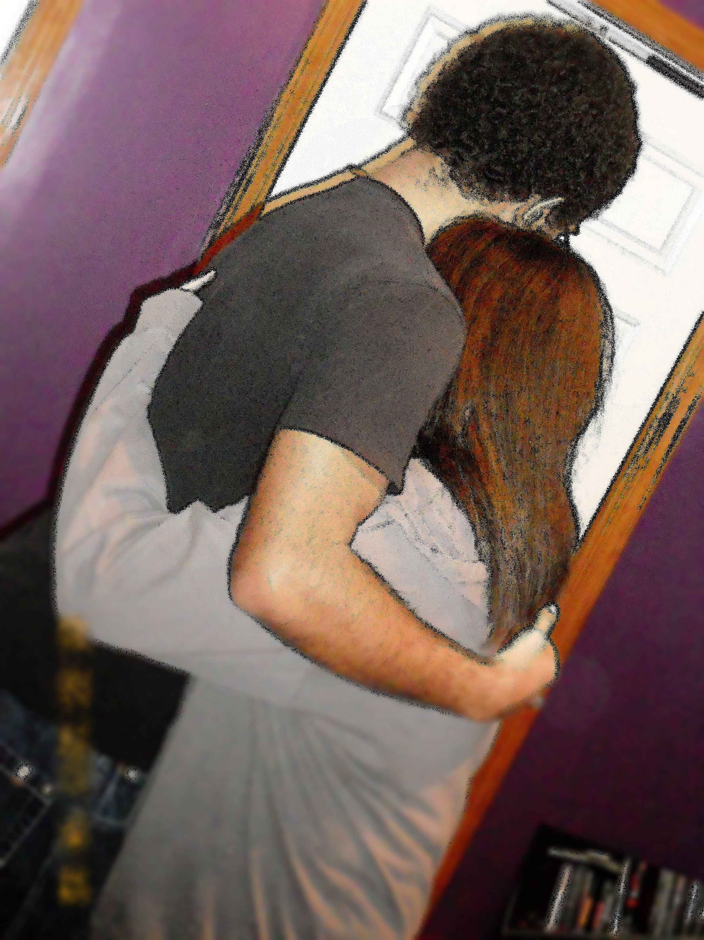I yank my arm back from her death grip. My temper was rising. I couldn’t take this anymore. “At least, i still love dad! He may not be here but he is still in my heart! Can you say the same?!” I left the broken frame on the floor and walked to my sisters’ room.

I walk through her door without knocking. I soon regret it. The scene i walk in on is so intimate and touching. A young, strong, and built man is standing holding my sister in his arms. He holds her with such caring and loving hands. My sisters innocent face lying on his chest.

They soon notice me standing there; they separate but with resistance. I can’t help but notice he has a strong jaw line but that’s not what catches my attention. It’s his eyes; they have this gentleness to them. They aren’t hard looking or in pain. His eyes have love in them. The love isn’t for me but for my sister.

“Umm... Sheala, can I speak with you for a moment?” She reluctantly followed me when I walked outside her bedroom door. When she is standing fully out of the door frame; I shut it. I take one look at her and notice she is here in body but her mind is still in there with that boy. “What did I just walk in on? Who is he? Does De-mom know he is here?” I throw the questions at her like it’s an interrogation. I can’t help but feel protective over her. I don’t want anyone to hurt my sister; especially some guy.

“His name is DeWayne. He is so amazing, Clara. I’ve known him for years but i've never felt like this for him till now. He knows what my life here is like and yet he still wants to be with me. Please, don’t tell mom. She would lock me in my room for days again. I’m begging you not to tell her!” I was looking at the same face as I was a few days ago but something had changed. I could see joy lighting up her face. How could I, her big sister, take that joy away? I have been searching for that same joy ever since my messed up. I hug her tight to me because I have something I must tell her that might change her view on me, but not at this moment.

I let her go on back to DeWayne after a few more minutes of me warning her to take it slow with him. As her door closes behind her, I hear the front door open and slam shut again. De-mom only ever seems to come home to get more cash than leaves without a “Bye girls” Or even an “I Love You”. I walk silently to the shattered pieces of a frame that holds a picture of lost memories, which can never be put back together.

January 14th
I have this horrible fear of heights. I’ve had it basically my whole life. I’m not proud to admit that i'm scared of something so childish but I am. I can’t help it. When I get up really high then I start to freak out and start to panic. I can see the hill of snow coming in to sight. I’m starting to regret agreeing to this trip. I look over at Jakob and just smile. He was so excited when he asked me to go with him.

“Please baby! It will be so much fun. It will give you a chance to get away from all of the problems here.” His eyes were begging me to agree. I looked around my tiny room and stopped short when I came to a picture of my dad. My father use to tell me to go have an adventure every day and to never pass up a chance to laugh. I can feel the ugly guilt starting to form a knot in my throat. I swallow it and hold back my thoughts. I looked back at Jakob and could see he was waiting for me to break his excitement. I’ve done that a lot lately but not this time. “Okay. I’ll go skiing but on one condition.”

I look into the back seat and see Sheala asleep on DeWayne’s shoulder. She looks like a perfect little angel. DeWayne is looking out the side window with a sense of joy. I can’t help but feel like he is good for my sister. He has been with her every day since I first met him. De-mom knows of him now. That wasn’t a very good day for me. I had to fight to keep my sister from being locked up again. I guess this trip will be good for all of us. A chance to escape it all.

We are pulling into the parking lot. We pass little flags on light posts that read “Perfect North”. It certainly is perfect. The snow looks like a soft blanket. It doesn’t take long for us to pay for the ski lift tickets and all our ski rentals. We get suited up and get on our way. I’ve only skied here once before with my dad and sister. I miss that moment even if I had to stop skiing early cause of my fear.

We all start off on the small hills. They are filled with other skiers of all levels from first timers to professional. We all ski on the same hills for a few hours. Then the others wanted more of a thrill. They wanted to go on the higher hills. I told then I would go sit at the lodge till they were done. Plus, I didn’t want to put too much stress on the baby. Jakob understood the baby part but he still wanted me to face my fear one day.

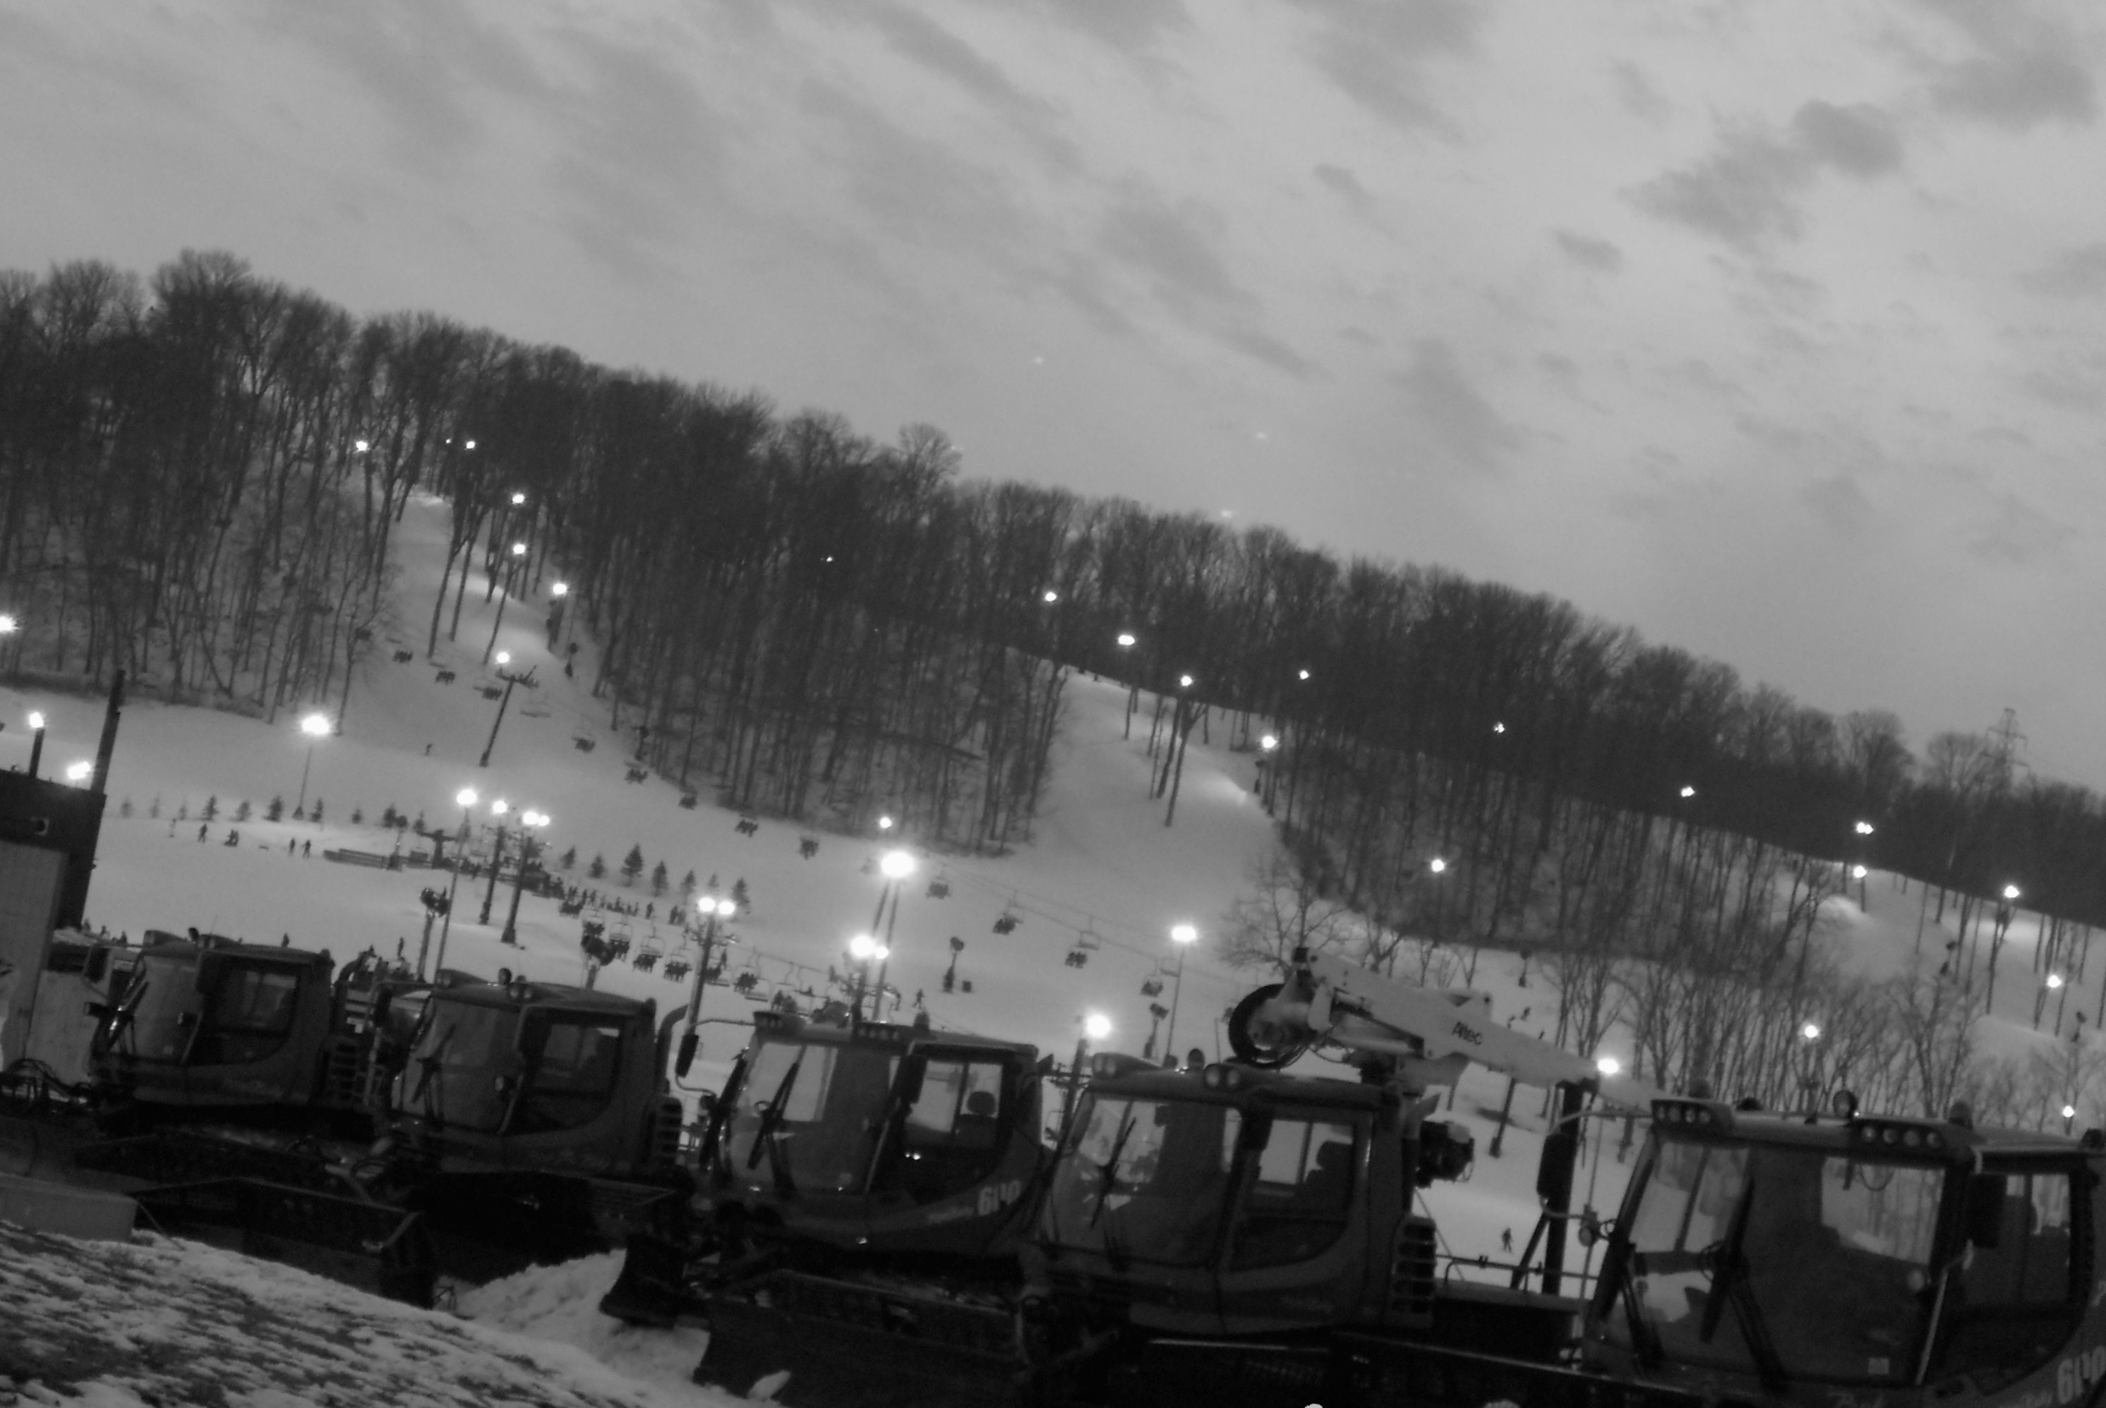I returned my rentals to the desk and found a bench near the edge of the lodge. It had a perfect view of the ski slopes. They are so lovely. The hills dip and rise like waves. Skiers coming down the slopes everywhere the eye can see. The huge snow plows are lined up in front of everything, just in case of snow. It’s like god put a small piece of heaven on earth with a hint of man put in. Well, if heaven was snowy and blowing cold winds. This place can take your breath away in beauty and frigidness.

I look to my right and notice that Sheala is sitting next to me. “I thought you went skiing with the guys? You didn’t have to come with me if you thought I was going to be lonely.” She looked up at me with the brown eyes that i've seen since we were little. She had tears forming on the side of her eyes. I took her into an awkward side hug but it was the only comfort I could think of at the moment. “What is wrong?” Did DeWayne do something?”

She pushed away and looked at the ground. “It’s not DeWayne. It’s you. Why didn’t you tell me about you being pregnant?” I almost started to cry with her. I felt this weight lift off my shoulders that I hadn’t noticed was there. “I was actually going to tell you later today. Wait, how did you find out?” It couldn’t have be Jakob that told her. He knew I was going to tell her today. DeWayne couldn’t have because he doesn’t even know about it. Who could have told her?

“I overheard you and Jakob talking about why you could go on the higher hills. I thought I had imagined what you had said but then I asked Jakob. He mentioned how you were going to tell me later but saw no point if I already knew. I love you Clara. You’ve been my big sister and like a mom to me since mother stopped being one. Why didn’t you tell me when you found out?” I couldn’t answer that and I didn’t need to. At the time, I was going to say something, the boys showed up.

They were in their cloths and didn’t have on their ski boots. They must have returned them before they came and found us. They were out of breathe and panting. “Gosh, did you run all the way here? What’s the big rush?” I was ready to go drink some hot chocolate, by the fire, in the lodge. I looked at Jakob and realized he had that look on his face. The look he gets when he has to say something he doesn’t want too. I had this sick feeling in the bottom of my stomach. “Your mom called. She’s at the hospital. Something’s happened.”

January 14th
(Night)

Rushing through the hospital doors wasn’t the best feeling in the world. I’ve never liked the smell or feel of them. It’s like death is lurking around every corner. I ask the nurse at the front desk what room Lilly was in. I run to the elevator and slide through just before it closes. I slam the button that has a black four on it. The elevator jumps to life. I couldn’t help but think of how bad she may look.

Getting the news from Jakob that my older sister Lilly was in the hospital, she had been beat up by her Ex-boyfriend, wasn’t the best feeling in the world. She may have her problems but I wouldn’t want her to die. I had made us leave and rush here. Sheala didn’t want to see how bad it was so I made the guys take her back home and stay with her till I got there.

I was at room 417. It was the room number the front desk had told me she was in. I slowly pushed the door open. The room was a pale yellow with floral border paper. It had the same smell of death but with a hint of lavender. In the bed, Lilly lay with monitors and IVs connected to her. She was blue and black from head to toe. She looked so fragile compared to: the strict, bold, adventurous sister I had grown with.

I stepped closer but didn’t dare touch her. I didn’t want to cause her anymore agony then needed. I couldn’t help but think that if my dad was here then he would know what to do. I was at a loss for words. I was so wrapped up in my own thoughts that I didn’t hear the de-mom walk in.

She was dressed in a mini skirt and a tank top. Her fishnet stockings were torn and her hair was a wreck. I was appalled at her clothing. It was obvious her mind was completely gone with the drugs. “Finally glad you showed up. I was getting bored waiting to see if she was going to die. I mean she could at least have the decency to die quickly. I’ve got other plans.” She said it with a lazy smile. I couldn’t believe what I was hearing. My temper flared.

“I think you should leave. Now!” My tone was harsh and to the point. I wasn’t going to listen to this while my sisters life hung in the balance. I gave de-mom a cold look. She looked at Lilly with disgust and walked out. I looked back at Lilly. She looked so young, even though she is about seven years older than me.

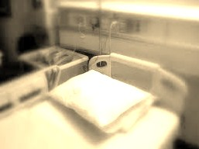I was caught off guard when I heard a loud beep that kept on continuously. I looked at the monitor and realized it was her heart monitor. She had flat lined. It all happened so fast. She was here and then gone. The doctors rushed in and pushed me out into the hall.

I couldn’t fully grasp what had just happened till Beth came into my view. It had been about thirty minutes since the flat line. The doctors had said she just wasn’t strong enough to hold on any longer. I was hurting in my heart but I couldn’t imagine Beth’s pain. Lilly and Beth were just like Sheala and I. We would die if the other one did.

I was sitting in a soft arm chair with Beth sitting next to me. I was rubbing my belly trying to think of something to say. All of a sudden the baby starts to kick. It wasn’t some ordinary kick. It slightly felt like it was trying to tell me something. I got up and walked down to the vending machine. On my way back, I heard a loud boom then screams erupted.

January 17th

We held the funeral and it seemed like everyone that came was just some strangers face. I was still in shock over it all that I didn’t talk the entire service. I didn’t want to let them go. Not Lilly and Beth. The screams were still fresh in my memory.

I had just rounded the corner of the hallway that went into the lobby where Beth and I had been sitting. When I got closer to my seat, I noticed blood and chunks of some meat laying everywhere. Where did all of this come from? When I glanced over I noticed where the source of the mess was from. The whole right side of my sister’s head had been blown off. I just couldn’t believe what I saw. My sister had taken her life because she couldn’t face the fact that our other sister had died.
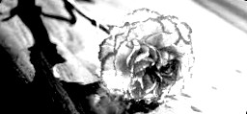
It was hard to tell Sheala. She didn’t take it very well. I didn’t do much during the funeral but the only thing I really could do. I took the only flower I had and laid it to rest with my older sisters.

______

My heart feels like a boulder had crushed it. I was about to lose my little sister when I had just watched my older ones get buried. It’s different because Sheala isn’t dying but she will wish I was dead after I tell her the truth. I just need to tell her cause she blames herself.

The park has always been lovely in the summer. It would be sunny all day and people would be out enjoying every bit of it. Not today though. It’s still frigid winter. The trees have no leaves or life to them. The ground is cold and frozen. There is no sun, just gloomy clouds. To me, life is just like the seasons. We all have our good times but the bad come around sometime or later.

Sheala is sitting on the bench next to me. She knows something is wrong but doesn’t know just how bad it is. I don’t even know how to start this conversation. We are both still full of grief over our sisters. I don’t think i've had a full night’s sleep in a while. “It was my fault.” I couldn’t bring myself to look at her when I said it.

“What do you mean, it’s your fault? You haven’t done anything. You’re my only big sister now. You are the only person I truly trust with everything.” She had such love in her voice. She truly thought highly of me when she shouldn’t have. All of this tragedy is my doing. I was the one responsible for the cause of it all.

“The night before dad died. I had borrowed the car for a few hours. I had snuck out to go see Jakob. I know it’s stupid and I could have gotten caught but I just had this urge to see him.” My mouth felt like it was getting dry. I choked on every word I said.

“Okay. So you snuck out. What does that have to do with anything being your fault?” Sheala had such confusion on her face. I know this will hurt me but it will help make her feel better about it all.

“On my way back home that night, I had noticed something was wrong with the car. It would drive fine but the brakes seemed a little off. I dismissed it as my imagination. I … I was the cause of dads accident on the way to pick you up. If I had told him about the brakes then he would have drove the truck instead.” My heart was beating so fast. I was breathing so hard that I thought I might pass out. “I was just so scared that I would get in trouble for sneaking out. It’s my fault dad is dead.”

I hadn’t even noticed I had been crying till Sheala’s arms went around me. I felt so empty. I hadn’t told anyone that. Jakob knew I blamed myself but didn’t know why. I didn’t understand why Sheala was still near me. How could she not be repulsed that I was the reason our dad was dead? Did she not understand that?

“It wasn’t your fault. I’ve thought over this a lot. I know you want to disagree and say that it was your fault; it wasn’t. I’ve blamed myself and you the same with yourself. It wasn’t anyone’s fault. He died because that’s what happens in an accident. If it was his time to die, no matter what we did different, he would have still died.” He face was so calm. She had finally come to peace with the death of our father. I wish I could do the same.

January 20th

I hated my English class. The only good thing about it was I was able to sleep. I knew some of the stuff the teacher was already teaching. I may hate English class but I loved to write and read. Books were my safe haven. They would take me away from my reality and put me in a different place. It was like my own escape world.

Sitting at my desk, listening to the teacher talk on about stuff I didn’t need to learn, I started to think about de-mom. She hadn’t been around since the hospital. I was surprised not to see her at the funeral. I was starting to wonder if she was dead. I doubted it.

I could only barely remember what it was like with de-mom before dad’s accident. I do remember how she had a face that was so beautiful. I would use to wish to grow up to be just like her. Things have surly changed. I wonder what things would be like if dad was still here.

I usually stay after school in the library for a while but I had to get on home. Sheala had been sick this morning so she had stayed at home. Jakob had picked me up outside the school and was driving me to check up on her. Then we were going out to eat. Today is our two year anniversary and we wanted to do something special. We were going to take all my sisters out with us to celebrate but that would never happen now.

I hoped out of the truck as soon as he pulled into my drive way. I came around and kissed him. “I’ll be right back. If i'm not out in fifteen minutes then come recue me.” I was smiling because it had made him laugh. I loved when he smiled. It lights up my world.

Walking away from the truck and closer to the house, I got a feeling that things weren’t right. I opened the front do as always. Then my baby kicked. Just like it had at the hospital. Something was definitely wrong. I closed the door behind me with a soft click. I knew this wasn’t going to be good.

I walked down the hallway toward the living room. It was so quiet I could hear the clock in the kitchen tick tocking. I finally reached the entry way to the living room. What I saw was something that I hadn’t expected. Sheala was tied up lying on the couch pasted out. I rushed to her and untied the knots. They were so tight that they had begun to cut into her flesh. She had a cut across the top of her head and probably had a concussion.

I didn’t get the chance to wake her up before I heard a clack of a gun being cocked. I slowly turned to face whatever lunatic would do this. Who would come into our house and do such a thing? What I saw were the same brown eyes I had known my whole life. Our beloved De-mom.

I was so shocked. I mean we were her daughters. She shouldn’t be holding a gun to us. I took a step back. The gun went off. It barely missed me going into the wall behind me. I ran down the hallway. I could feel her deciding on who do kill first; me or Sheala? I had to make a quick decision and decided to grab a knife out of the kitchen. De-mom must have chosen me as the bigger threat. When I excited the kitchen she was coming down the hall.

I ran into the dining room. De-mom wasn’t going to run after me. She was too messed up on drugs to run. I ran through the side door of the dining room and up the stairs. I decided to hide in a closet in behind a desk that had been put in it. It was a tight squeeze with my baby belly. I just knew I couldn’t let her kill me and my unborn baby.

“I know you’re up here Clara! You can’t hide from me. You’re going to die no matter if you like it or not!” She was screaming through the house. Where is Jakob? Shouldn’t he have heard the gun shot? Just like he could read my thought, I heard the front door bust open.

“CLARA!! Where are you? What’s going …?” I heard a shot fired. I sat quietly hoping to hear movement but didn’t hear anything. Is Jakob dead? No. He couldn’t be dead. The silence grew louder. I could feel a sob start to boil up in my throat.

I heard footsteps coming up the stairs. They were light and small. I could feel every part of me start to shake. Is this how i’m supposed to die? “Please, I don’t want to die and I want my baby to have a chance at life!” I couldn’t help but pray. I was scared.

The closet door opened. I hadn’t even registered what had happened till I looked down at my arm. I hadn’t even heard the gun fire. De-mom had took a wild shot into the closet and it went through the aluminum desk and into my arms. I screamed in agony. She came and pulled me up by my hair. She looked me in the eyes and it sent shivers down my back. Her eyes were black with red veins showing in them. She was high and on drugs.

“It’s time for the whole family to finally be together, Clara. If your father and sisters can’t live then we can’t either.” She brought the .45 pistol to my heart. I was crying cause of my fear for my baby and myself. Then I remembered the knife. I grabbed hold of it tight and with all the strength I had in me, I shoved the knife into whatever was left of her heart.

De-moms face was full of shock. She looked down at the knife and dropped the gun. She stammered backward. She stepped back to far. I tried to catch her arm but it was too late. She had fallen backward off the upstairs balcony. I ran to the railing and looked down. She lay there on the down stairs floor limp and lifeless. Then I saw Jakob.

I rushed down the stairs. I kneeled down beside him. He was facing down so I rolled him over. He had a shot to the side of his torso. It was bleeding badly. I grabbed his cell phone and dialed 911.

January 25th

After all the cops showed up at the house that day, everything went by in a blur. They asked what happened and said they wanted me to get my arm checked out. The paramedics said the bullet went right through my arm and didn’t hit any main arteries. They bandaged me up and went to work on getting Jakob into the ambulance.

He went through surgery. The doctor said he was very lucky that the bullet had missed his organs. He gave me a container with the bullet remains. Jakob found that pretty awesome when he woke up. Sheala had only a cut across the head. She said she couldn’t remember anything that had happened except being hit in the head.

Now standing over de-moms casket, I realize just how things can fall apart after someone’s been ripped from their lives. I don’t blame myself for my dad’s death anymore. I still miss him more now, then ever. I hadn’t noticed DeWayne come up next to me till he touches my arm.

“I’m taking Sheala back to my apartment. She can stay there while you work out what is going to happen next.” He was looking at me with such puppy dog eyes. He had rushed to the hospital when he had heard what happened. He was more concerned about Sheala then anyone but he was still worried about us. I nodded slightly. He hugged me then went on. I looked back at the casket that held the remains of the woman that gave me life.

Everyone who had come to the funeral had already left. I knew Jakob was back at the car waiting for me. I just couldn’t leave yet. I looked around and made sure I was alone.

“I know you were broken. I just wish I could have healed that broken piece of you. I don’t hate you for what you did. I know the drugs didn’t help your broken place. Instead they made it worse.” I could feel tears begin to form “I just want you to know that I don’t blame you for any of the tragedy that had entered my life. I know you’re with dad, Lilly, and Beth now. One day we will all see each other again. Please, watch over us and my baby.” I turned to walk away but I couldn’t. I had to say one last thing.

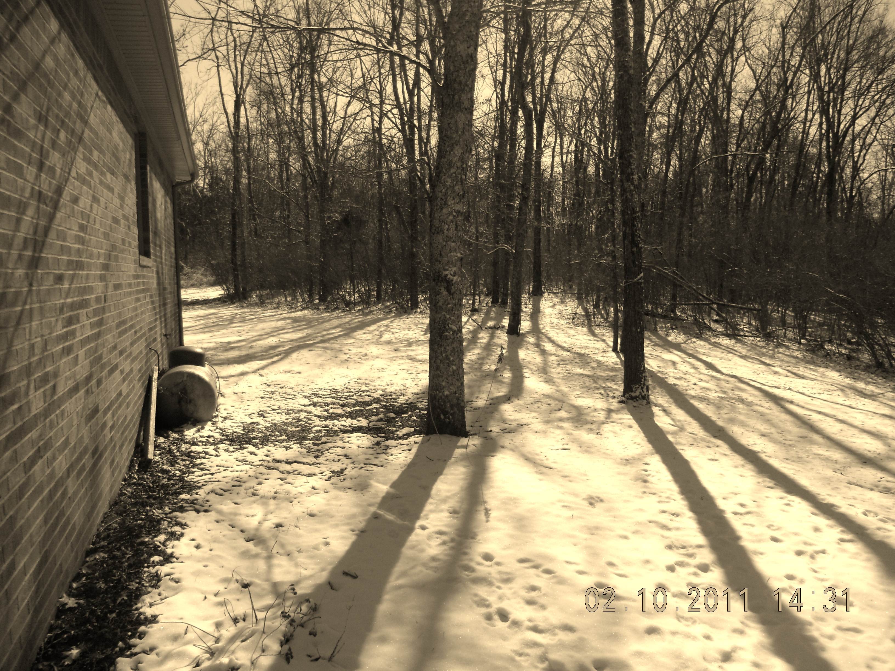I touched the casket and closed my eyes, letting one tear fall down my cheek. “I love you, mom.” I let my hand fall and I walked away ready for whatever challenge or tragedy life throws at me. It’s a long path to walk in life.

