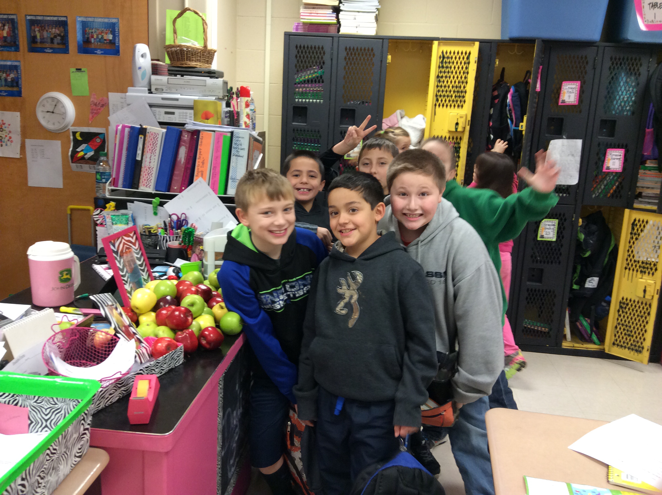SPOTLIGHT IS ON...
Kate for being Student of the Week!
Kate did an amazing job leading our class this week and setting a good example for her peers. Kate is a joy to have in class and works well with all her classmates!

Reading/ELA
This week We will be reading "Hottest, Coldest, Highest, Deepest" while learning how to answer questions referring to the text to improve comprehension. We will also learn how to compare and contrast information from the story.
Our Grammar focus this week will be Subject and Object Pronouns.
Students will be spelling words with vowels and r.
Spelling & Reading Test Friday 2/13/15

Math
In Math this week, we will continue multiplication and division fact mastery. We will have a fact quiz every day in which 60 problems must be correctly completed in 2 minutes or less. Each child will progress at their own pace until all facts are mastered.
We will finish our unit on fractions in class this week. We will begin our graphing and data unit next week.

Weekly news
Third Grade | Ms. Dadisman | February 6-13 2015

Important Dates
February 13th Valentine's Day Party (more information to come)
February 16th We will be in school on President's Day to make up a snow day.

Reminders/ Other Information
- I have updated my web page on the Anderson County Website with important dates and I will also be attaching a copy of the newsletter and any other forms sent home.
- www.studyisland.com is an excellent resource for your child to learn and practice math, ELA, science, and social studies. Science can be accessed through 4th grade and social studies can be accessed through 5th grade.

Weekly Homework Due 2/6/15
Reading- read an AR chapter book for 25 consecutive minutes, 2 days per week. When you finish the book, you will take an AR test at school. Record on a sheet of paper their name, the date, Title of the chapter book, Author, the level or color of the AR book, and page number they start on and page number they ended on for each of the two (2) sessions. Spelling- complete 2 activities. The first activity has to be to write their words in their assignment book by Monday and the 2nd assignment is your child's choice on an activity in which they are some how spelling the words orally or writing. This activity has to be recorded by your child writing what you and (s)he did to practice in a complete sentence.
Math- practice multiplication facts that your child is currently being tested on. This will be different for each child so they will have to tell you which test they are taking next. This assignment will also need to be recorded by writing a complete sentence describing the activity completed and the dates in which your child practiced.

- Please return the green emergency snow day form as soon as possible. I have attached a copy of this to my web page.
- Please send in ear buds or headphones, labeled with your child's name, to use during our listening center as soon as possible.
- Please make sure you are checking your child's assignment book nightly and writing your initials or signature each day. You may also write any note to me in the assignment book.