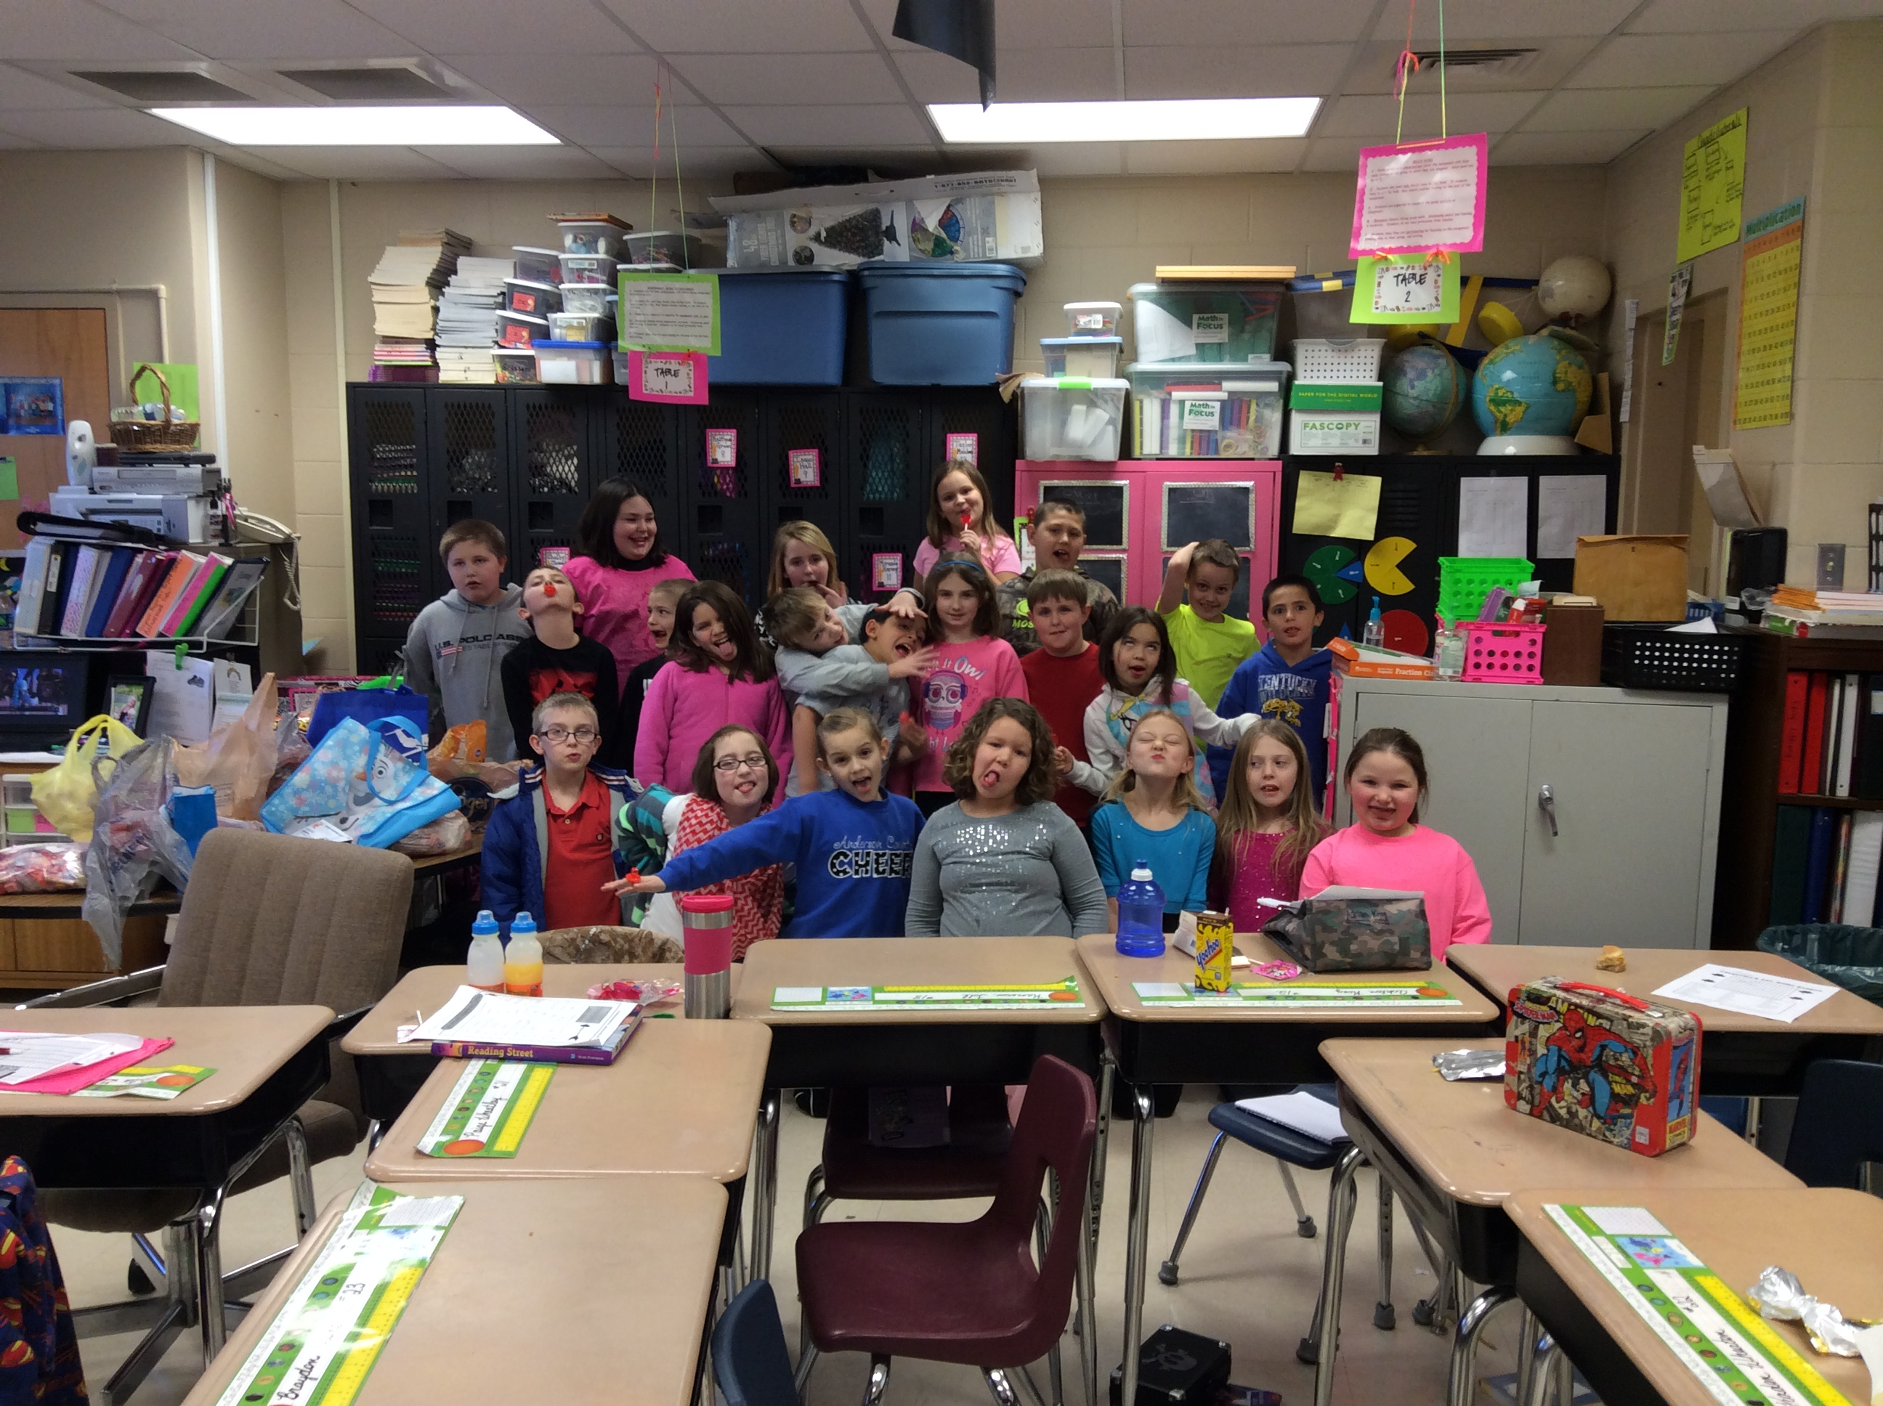

SPOTLIGHT IS ON...
Ashton for being Student of the Week!
Ashton did an awesome job setting a good example for his peers and leading our class. Ashton is a very smart young man and a pleasure to have in class.

Reading/ELA
This week We will be reading "Rocks In His Head".
Our Grammar focus this week will be Possessive Pronouns
Students will be spelling words with prefixes pre-, mid-, over-, out-
Spelling & Reading Test Friday 2/20/15

Math
In Math, we will continue multiplication and division fact mastery. We will have a fact quiz every day in which 60 problems must be correctly completed in 2 minutes or less. Each child will progress at their own pace until all facts are mastered.
We will be learning about geometry in math this week.

Weekly news
Third Grade | Ms. Dadisman | February 13-20, 2015

Important Dates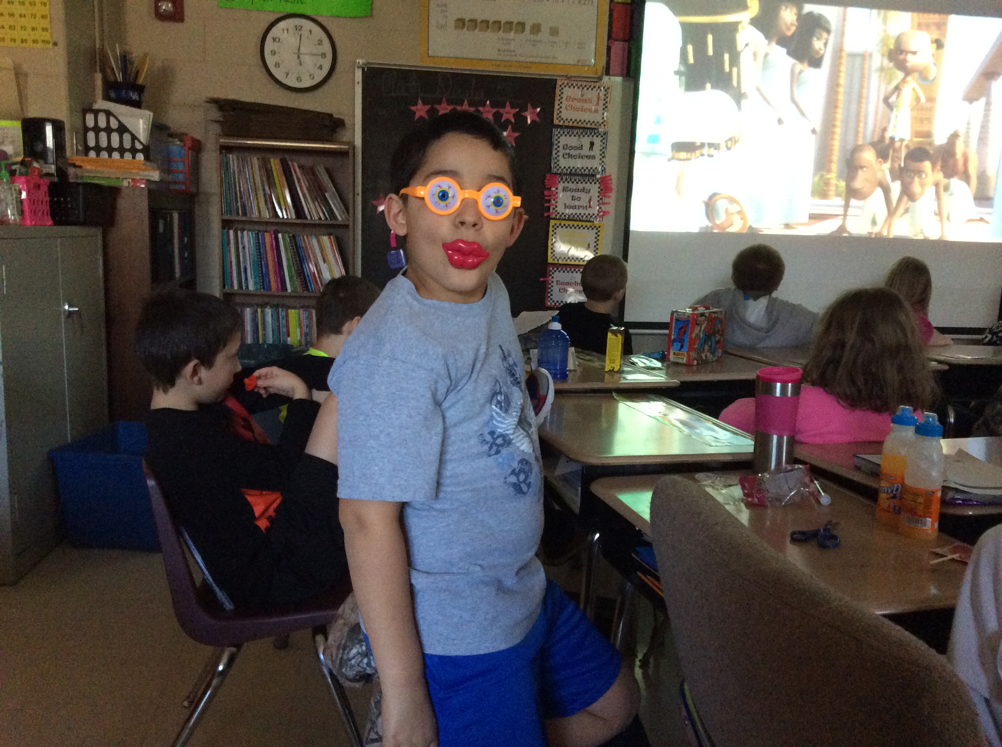
February 16th We will be in school on President's Day to make up a snow day.
February 17th Progress Reports go home
February 20th Club Day

Reminders/ Other Information
- I have updated my web page on the Anderson County Website with important dates and I will also be attaching a copy of the newsletter and any other forms sent home.
- www.studyisland.com is an excellent resource for your child to learn and practice math, ELA, science, and social studies. Science can be accessed through 4th grade and social studies can be accessed through 5th grade.

Weekly Homework Due 2/20/15
Reading- read an AR chapter book for 25 consecutive minutes, 2 days per week. When you finish the book, you will take an AR test at school. Record on a sheet of paper their name, the date, Title of the chapter book, Author, the level or color of the AR book, and page number they start on and page number they ended on for each of the two (2) sessions. Spelling- complete 2 activities. The first activity has to be to write their words in their assignment book by Monday and the 2nd assignment is your child's choice on an activity in which they are some how spelling the words orally or writing. This activity has to be recorded by your child writing what you and (s)he did to practice in a complete sentence.
Math- practice multiplication facts that your child is currently being tested on. This will be different for each child so they will have to tell you which test they are taking next. This assignment will also need to be recorded by writing a complete sentence describing the activity completed and the dates in which your child practiced.

- Please return the green emergency snow day form as soon as possible. I have attached a copy of this to my web page.
- Please make sure you are checking your child's assignment book nightly and writing your initials or signature each day. You may also write any note to me in the assignment book.